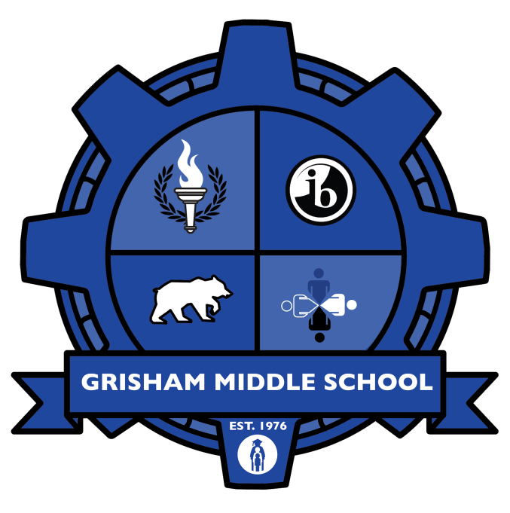

IB COMMUNITY PROJECT
2018-2019
Student Guide

Name: ________

Group Members (if any): ______________________________________________________________
_____________________________________________________________________________________

NAME OF ASSIGNED SUPERVISOR: ____________________________________________________

IB Mission statement: The International Baccalaureate® aims to develop inquiring, knowledgeable and caring young people who help to create a better and more peaceful world through intercultural understanding and respect.

TABLE OF CONTENTS

Cover page | 1
Table of Contents | 2
What is the MYP Community Project | 3
Process Journal | 4
Understanding Global Contexts | 5–6
Approaches to Learning (ATL) Skills | 7-8
IB Learner Profile | 9
IB Community Project Timeline | 10
Community Project Checklist | 11
Pre-Project Reflection (Process Journal) (phase 1a) | 12
Investigating (phase 1b) | 13-14
Planning (phase 2) | 15-16
Taking Action (phase 3) | 17
Final Reflection (phase 4) | 17–18
Presentation & Exhibition | 19
How Will My IB Community Project Be Graded? | 20–23
Academic Honesty Form | 24–25
Community Project Proposal | 26

Any questions: email IB Coordinator Ms. Browning at dana_browning@roundrockisd.org

What is the IB MYP Community Project?

The 8th Grade Community Project is an independent student project. It is a requirement of the International Baccalaureate Organization (IB).

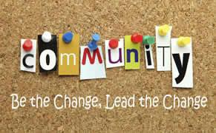

THE PURPOSE:
Students will apply, and evaluate, the skills and knowledge they have
acquired throughout their years at Grisham Middle School by engaging with their
community to make it a better place. Students will generate new insights and
develop deeper understandings of the world in which they live through an in-depth
investigation, and communicate their findings to peers.

Participants: All 8th graders are expected to participate in the project. Students may work individually, or in groups of up to three.

Supervisor: All projects will be overseen by a campus staff member - will be assigned mid-January.

Example projects:
- performance art (i.e. dance, music, acting)
- visual art (i.e. sculpture, mural, portraits, PSA)
- multimedia piece (i.e. PSA, music video, animated movie)
- old-school writing (i.e. speech, letter to government official or newspaper, proposal to an organization)
- direct action (i.e. volunteer, start a business)
- scientific/technology innovation (design and create a model to solve a problem)
- YOU may be creative with another format…discuss with your supervisor!

Process Journal

As you go through the process of the community project, you will need to maintain a
record of your progress. It is your choice as to how you will do this. Every 8th grader
must keep his/her own process journal, even if working with a group.

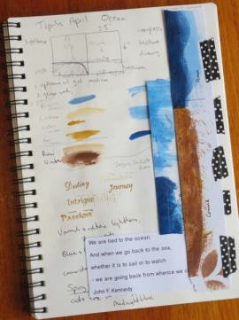
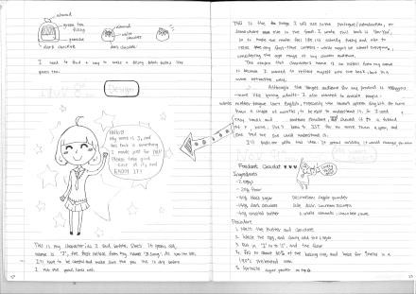
What is included in the process journal?
  - Reflections of your understanding of the topic
  - Reflections of your understanding of the global context through which you will work with the topic (connecting your topic/project to the global context)
  - Reflections of your understanding of your ATL skills
  - Drawings, diagrams, doodles, clippings, pictures
  - Meeting notes: intentions, next steps, accomplishments, brainstorming, discussions, arguments (keep it civil!), reflections on your personal growth through these meetings
  - Record of sources/notes from research
  - Planning information: materials, contact names and numbers, dates, times, locations of meetings and events
  - Musings on all of the above (the more humorous the better!)

You choose how you will maintain the process journal (but make sure you use it regularly as you go through the project and can share it with your supervisor):
- personal notebook/scrapbook
- video
- audio recordings
- google docs, word, other online record keeper

Understanding Global Contexts
Whichever topic you select, you must also choose a Global Context through which to understand it. Global Contexts give background to the topic (explain the situation & people the topic impacts).

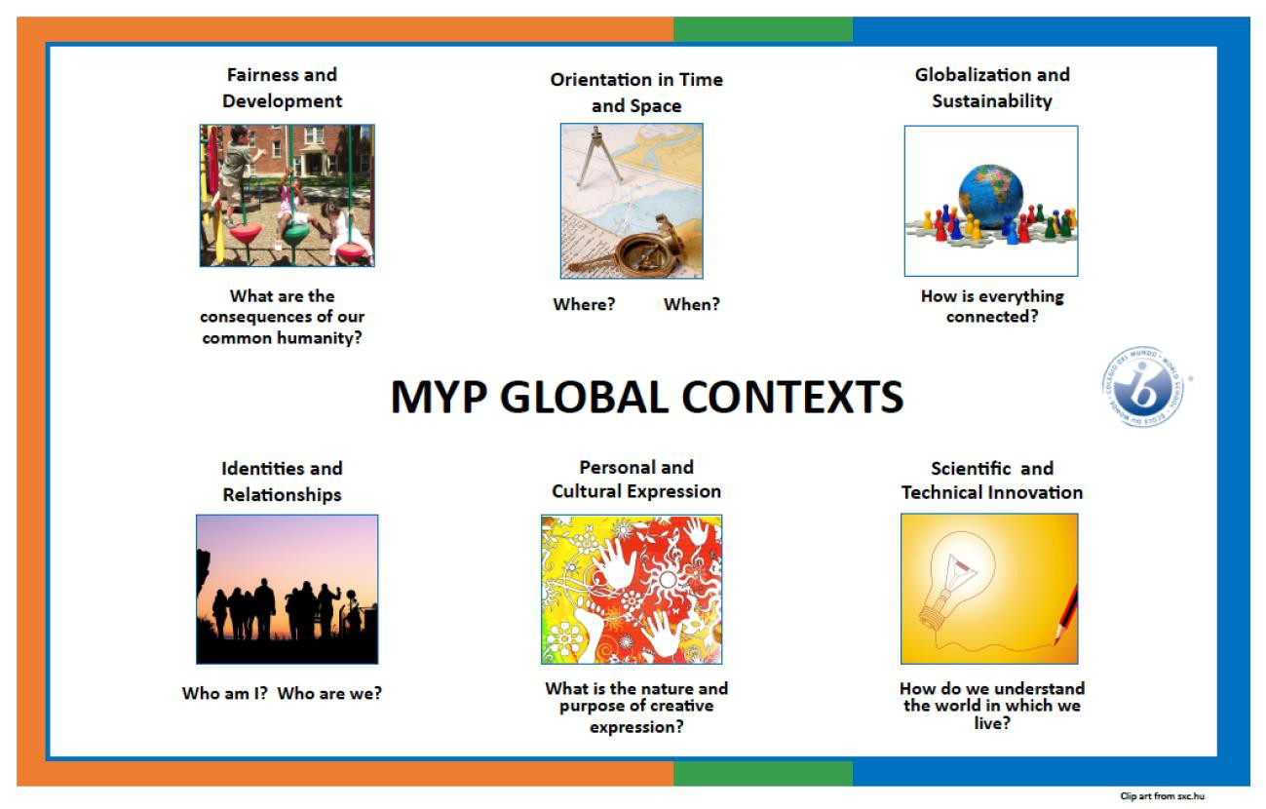

Identities and Relationships  (psychology, sociology, theology, cultural anthropology)  Explore: identities; beliefs and values; personal, physical, mental, social and spiritual health; relationships including families, friends, communities and cultures; what it means to be human | TOPIC EXAMPLES  - cyberbullying  - keeping traditions alive  - gun culture/violence in communities  - mental health  - benefits of exercise  - lifestyle choices  - types of families
Orientation in Space and Time  (history, cultural anthropology, archaeology)  Explore: personal histories; historical events/turning points; discoveries; explorations and migrations of humans; interactions of people with civilizations from local, regional and global perspectives | TOPIC EXAMPLES  - immigration patterns  - imperialist strategies  - impact of scientific discoveries  - one family’s journey during the Great Migration  - Syrian refugee crisis  - oral history traditions

Personal and Cultural Expression
(art, dance, music, graphic design, interior
decoration, architecture, fashion design,
tattoo artistry, cosmetology)

Personal and Cultural Expression  (art, dance, music, graphic design, interior decoration, architecture, fashion design, tattoo artistry, cosmetology)  Explore: the ways in which we discover and express ideas, feelings, nature, culture, beliefs and values; the ways in which we reflect on, extend and enjoy our creativity; our appreciation of ‘beauty’ | TOPIC EXAMPLES  - visual art  - architecture  - performance art (dance, music)  - multimedia  - games  - fashion
Scientific and Technical Innovation (engineering, aviation, construction, genetics, environmental conservation, physical anthropology, physics, biology, astronomy)  Explore: the natural world and its laws; the interaction between people and the natural world; impact of science and technology on communities and environments; impact of environments on humans; human adaptations and innovation; how humans use their understanding of the natural world | TOPIC EXAMPLES  - materials for bicycles  - simple machines in daily life  - genetic engineering  - industrialization  - climate change  - renewable fuels  - city planning  - using math to solve crimes (data/profiling)  - light and sound energy  - space travel/exploration
Globalization and Sustainability (politics, environmental conservation, economics, foreign relations)  Explore: interconnectedness of human-made systems and communities; relationship between local and global economies; opportunities and tension created by globalization; impact of globalization on the environment and communities | TOPIC EXAMPLES  - impact of climate change on developing countries  - Greek austerity measures  - education policies around the world  - NAFTA  - Opening relations with Cuba  - Joint Comprehensive Plan of Action with Iran
Fairness and Development  (counseling, law, politics, economics, education, environmental science)  Explore: rights and responsibilities; sharing finite resources; access to opportunities; privilege; peace and conflict resolution | TOPIC EXAMPLES  - fair trade  - open-market economies  - economic regulation  - capitalism/socialism  - free college tuition  - ghettos  - public v. private schools  - Texas/Africa water contamination  (THINK – Water Well Project!!)

Approaches to Learning (ATL)

IB Approaches to Learning are skills that help you learn. You may hear them called “soft-skills”. If you practice, and apply these skills in the real world, you will become a life-long learner.

Why should this be a goal of yours? Because even though you may graduate high school and college, you’ll still need (and hopefully want) to learn!

New jobs, new life roles, travel to different countries, world events; lots will happen and with these skills you will be better prepared to understand the changes and your role in them. Plus, you’ll be practicing them for this project, so may as well put them in perspective!

APPROACHES TO LEARNING (ATL skills) – here are some examples
Thinking Skills | - generate ideas  - identify problems  - ask questions  - identify bias  - plan  - come up with innovative solutions  - apply knowledge and skills to different situations  - evaluate solutions and ideas  - reflect on learning
Self-Management Skills | - meet deadlines  - set goals and create a plan to accomplish them  - keep information organized  - find balance in life (effectively cope with stress)  - don’t give up  - effectively deal with emotions  - think positively about self  - effectively deal with criticism and setbacks
Research Skills | - access information  - find information using different media  - evaluate sources for bias  - take notes in own words (paraphrase)  - synthesize information from various sources (put ideas together)  - create a “Works Cited” page with correct format
Collaboration Skills – how well do you work with others? | - respect other’s point of view  - respect other’s differences  - be empathetic  - resolve conflicts  - be fair  - take responsibility for own actions  - make decisions  - create consensus  - speak up in a group  - help others  - develop cultural understanding and global awareness by engaging with learners of other cultures
Communication Skills | - speak respectfully to others  - give and receive feedback  - listen to others and consider/analyze their ideas  - use various communication techniques to make your ideas clear (verbal, gestures, diagrams, statistics, charts, graphs)  - write for different purposes  - organize information logically  - present ideas clearly and effectively

IB Learner Profile

The IB programme at Grisham Middle School aims to develop internationally minded people who, recognizing their shared humanity and shared guardianship of the planet, help to create a better and more peaceful world.

IB students strive to be:

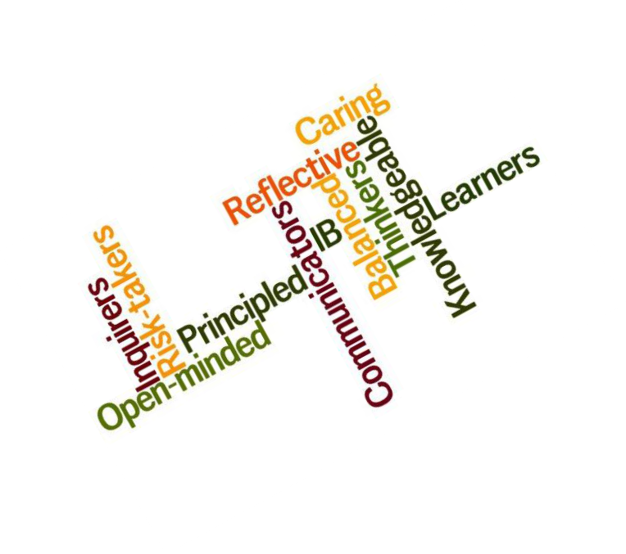

IB Community Project Timeline (At a Glance)
NOTE: There are only a few mandatory checkpoints. Use the timeline as a guide to keep you on track
Criterion A | Criterion A | Criterion B | Criterion C | Criterion D
Pre-Project Planning  (Phase 1a) | Investigating  (Phase 1b) | Planning  (Phase 2) | Taking Action  (Phase 3) | Reflecting  (Phase 4)
December | January | February | March/ April | May
*Kickoff and generate possible topics  *Explore definition of community and service  *Review ATL skills (Approach to Learning)  *Review Handbook and CP Rubrics  *Start filling out your Community Project Proposal. | *Decide on need within local or global community  *Define and choose Global Context  *Define a goal to address the need  *Initial research period – select resources and gather information  *Record in process journal  *Meet with supervisor | *Develop a proposal of action  *Continue with research  *Work on the preparation for the service as an action  *Record in process journal  *Meet with supervisor | *Carry out the service as an action (direct, indirect, advocacy, or research)  *take pictures of action part of project (these may be used for your presentation and exhibition)  *Record in process journal  *Meet with supervisor | *Evaluate the quality of the service against the original proposal  *Reflect on your learning  *Prepare tri-poster for presentation, bibliography, select process journal examples  *Prepare for oral presentation  *Prepare for exhibition (minimum of 15 hours of service from phase 1-4  *Meet with supervisor
DEN – some den time will be given, but most of your work should be happening outside the classroom.  GET A PROCESS JOURNAL | Checkpoint #1:  Pg 12-14 &  BRING PROCESS JOURNAL  (Goal) Meet w/  SUPERVISOR | Checkpoint #2:  Pg 26 & BRING PROCESS JOURNAL  (Action Plan)  SUPERVISOR | Checkpoint #3:  (Action Completed)  BRING PROCESS JOURNAL  Meet w/  SUPERVISOR | Reflection, Report, Presentation, and Exhibition  IB COORDINATOR and SUPERVISOR  Exhibition: May TBD
While principled action may not always be clearly or immediately visible or measureable, it is important that students record and reflect on how what they have learned has impacted their attitudes and behaviors. (19, Projects Guide)
Thanks to Wedgewood Park IB School for many parts of this projects guide.

Community Project Checklist

As you complete the project, use this checklist as a quick guide to make sure you’re on task.

PRE-PROJECT Planning – phase 1a
_____Read Community Project Guide
_____Answer and explain the 3 Pre-Project Reflection questions in your Process Journal (pg.12)

INVESTIGATING – phase 1b
_____Decide on whether you are working in a group or individually.
_____Brainstorm and determine community need (problem to be addressed, pg.13)
_____Define a goal (pg. 14)
_____Decide on a Global Context
_____Reflect on your understanding of the topic within Global Contexts, ATLs, and Learner Profile
_____Meet with Supervisor at least once and fill out CHECKPOINT #1 – Google Form (supervisor will complete form)

PLANNING– phase 2
_____Develop an action plan (what are the steps you need to take to complete plan) project?)
_____Continue to research and record information about your topic
_____Contact any organizations/experts as needed (ask supervisor if you need help)
_____Organize the “action” (gather materials, find location for event, set up the date and time for the service, etc.)
_____Reflect on your understanding of the topic within Global Contexts, ATLs and IB Learner Profile Traits

_____Fill out your Community Project Proposal sheet (pg. 26) – must turn in a copy to supervisor
_____Meet with Supervisor at least once and fill out CHECKPOINT #2 – Google Form (supervisor will complete form)

TAKING ACTION – phase 3
_____Carry out the “action” – record how it went. What went well? What didn’t go as planned?

_____Reflect on Global Contexts, ATL skills and Learner Profile (How have you grown?)
_____ TAKE PICTURES – these may be used for your project tri-board (presentation and exhibition)
_____Meet with Supervisor at least once and fill out CHECKPOINT #3 – Google Form (supervisor will complete form)

REFLECTING / PREPARE PROJECT PRESENTATION – phase 4
_____Brief explanation of what your problem/idea was
_____ Get a TRI-BOARD to put together a VISUAL for the presentation and exhibition
_____Evaluate project against your proposal (Did it turn out as you’d planned?)
_____Reflect on your learning (Global Contexts, ATLs and Learner Profile)
_____Select several journal entries from the process journal (demonstrate your design/learning process)
_____Create a “Works Cited” page with proper format (use www.easybib.com)
_____Complete Academic Honesty Form (pg. 24-25)- must be turned in to supervisor

PRESENTATION / EXHIBITION
_____Complete project board for display
_____Present project / participate in the IB Community Project Exhibition
_____ CELEBRATE!! You are finished!

Pre-Project Reflection (Process Journal)

Now it’s time to get started! Choose the format for your Process Journal (it can be in paper form (a notebook or composition book), electronic (audio or video based), or another form that you choose.

Just make sure that all of your journal entries are stored in one place so that you don’t lose them.

In your Process Journal, answer the following questions honestly, thoughtfully and give examples if you can.

- Through which Global Context do you usually see the world (pages 5-6)? Explain.

- Review the list of ATL skills (page 8). Choose several that you feel you do well. Give an example or two.

Now choose one that you would like to work on…why do you want to work on this skill?

- Review the IB Learner Profile Traits (page 9). Which profiles describe you best? Why?

Explain how this project might help you develop some of the other profile characteristics.

At this point - decide if you will be working individually or with a group. If you are working with a group, the remainder of this project must be done in conjunction with those members.

INVESTIGATING

 | Needs of Different Communities
 |  | Our world is complex and there is plenty of work to do to make it a better
 | place. Different communities face different challenges. Use the space provided in
 | the chart below to brainstorm the needs (things that can be improved, fixed, or
 | created to make life better) of each community. Some ideas may overlap!
Home or School  (GRISHAM or  other) |  |  | Neighborhood or City or  County | State (TX) |  | National (U.S.) | International / Global

Once you have completed the chart, narrow your choices down to 3 ideas that
you/your group, are most passionate about. List those 3 ideas here:
Community Need_______________________________
Community Need_______________________________
Community Need_______________________________
After further discussion, choose the one idea you/your group would like to work on for
the Community Project.
CHOSEN Community __Need__________________

 | ** Process Journal Reflection**
4. | 4. Record in your journal how you/your group came to a decision about the
final topic. Reflect on the process and your ATL skills.
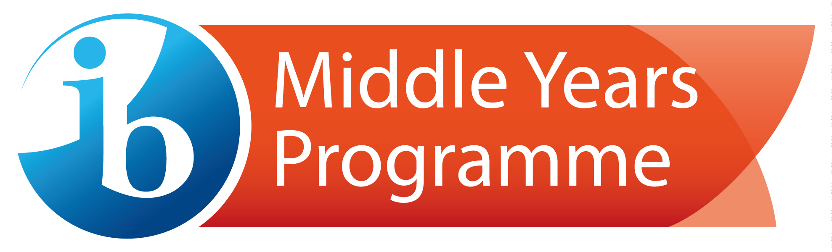

Decide on a Goal for Your Project
What do you want to do about this topic? Individually, or with your group, brainstorm, then choose a goal.
  - raise awareness (Do you want people to know about this issue?)
  - participate actively (Do you want to volunteer?)
  - create/innovate (Do you want to build something that will help?)
  - change behaviors (Do you want people to change an everyday behavior?)
  - call to action (Do you want to do something collectively about this issue?)

My/Our goal for the Community Project is .

Identify the Global Context

Your topic may vary depending on the Global Context through which you want to pursue the project. Review the Global Contexts and decide (with your group), which best fits your goal (above).

The Global Context for my/our project is .

 | **Process Journal Reflection**
5. |  | You/your group has chosen a topic, a goal for that topic, and a Global
Context. Reflect on the selection process (ATL skills) and explain how the
Global Context you chose fits with your topic.

PLANNING

Decide on the Action
Develop a proposal for action for the project (What action will you take to reach your goal?):

When you are clear on what you want to achieve, you will need to decide on an action plan to accomplish your goal.

**Process Journal Reflection**
- What are some specific tasks or activities you can do to develop your project? You can use checklists, rubrics, timelines, flowcharts or other strategies to prepare the proposal. Reflect on the ATL skills and Learner Profile.

Research
Now it’s time to begin your research. Keep your notes and sources in your Process Journal. Remember to look for reliable online sources. Don’t forget interviews with individuals involved in whatever your project is related to can offer valuable information and insight.

What are the causes of your issue? What are some effects of your issue?
Where does it occur the most? (Geography)

Who is involved/affected? (Population/Demographics) When is it an issue?
Are there individuals or organizations working on this issue?

Is there data (statistics, surveys, graphs) with information about this issue? Analyze it.

Some possible sources include: interviews, personal experiences and observations, surveys that you create and online resources.

**Process Journal Reflection**
- Reflect on your ATL skills, Global Contexts and the Learner Profile

Decide the “Action”
Once you have researched your issue, decide what you will do to reach your goal.

Here are some examples “actions” you can take:
- Submitting an editorial to a local newspaper
- The creation of an innovation (an invention)
- Collecting food items and delivering to a local food pantry
- Volunteer at a community organization
- Developing a proposal (ex: to help minimize homelessness in your community)
- Start a campaign against violence (via social media, website, petitions, etc)
- Publish a PSA (Public Service Announcement)

**Process Journal Reflection**
- Reflect on your ATL skills, Global Contexts and the Learner Profile.

Planning the “Action”

In your Process Journal, brainstorm the steps you will take to complete your “Action”.

Include:
  - Materials needed
  - Contact information of organizations/individuals
  - Where will you create/complete the action?
  - If working in a group, who will be responsible for what?
- Timeline and deadlines
- Step-by-step procedure of what you will do

**Process Journal Reflection**
- Reflect on your ATL skills, Global Contexts and the Learner Profile.

The next step is to complete your Community Project Proposal (located on page 26).

TAKING ACTION

Now it’s time to put your plan into action! Make sure to document what happens (pictures, videos, diagrams).

**Process Journal Reflection**
- How did it go? What went well, what could have been better? Reflect on your ATL skills, Global Contexts and the Learner Profile.

FINAL REFLECTION (write-up and tri-board creation)
Congratulations! You made it. This is the final stage of your project. This is where you will you will finalize all of the work you have done; research, findings, final self- reflection, opinion, final thoughts, etc…

•Brief introduction to your project (Discuss your goal and your original plan). This should be 1-2 paragraphs.

•Evaluate the quality of service as action against the proposal (Did the project turn out as you had planned? What went well? What didn’t go as planned?) 1-2 paragraphs.

•Reflect on learning (Global Contexts, ATLs and Learner Profile), refer to specific Process Journal entries. 1-2 paragraphs.

Questions (you may use several of these questions to help you decide what to put in your reflection) - (Answers should already be in your Process Journal!) for Final Reflection that also addresses the ATL (Approaches to Learning) skills.

- How did you decide which issue in the community to research and take an action on?
Was it personal?

- Did your action require you to plan and organize? If so, what was this process like?

- How did you use creativity to take action in order to meet your goal? (Creative Thinking)

- Did you collaborate with anyone? If so, what was that process like? If not, why not? (Collaboration critical)

- What was challenging about this project? What was easy about it? (Reflection)

- What did you learn about the community? Misconceptions? Affirmations? (Reflection)

- How did your research help you better understand the issue in your community? (Literacy, media literacy: videos, internet, transfer)

- As you reflect on your process journal, what would you change about the process or project, if you had the opportunity to do it over again? (Critical thinking, transfer)

- Did you meet your goal? If so, what is the evidence of your success? If not, why do you think you did not meet your goal (For example: Did your project end up going in a different direction?)

- What did you learn about yourself as a learner and as an active citizen in society? (Critical thinking, transfer)

- How will you use what you have learned in the future? (Critical thinking, transfer)

•Complete the bibliography/ works cited (correct format – Use easybib.com!!)

•Include several examples/ extracts (minimum of 4) from the Process Journal (i.e. challenges, epiphanies, data, and successes)

You should carefully select evidence (extracts) from your process journal to demonstrate learning/ development in all areas of the Community Project process:

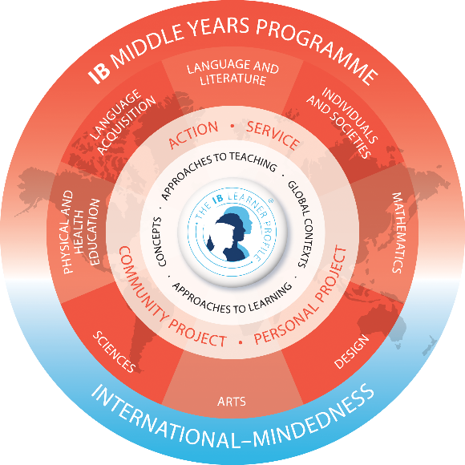
A. Investigating
B. Planning
C. Taking Action
D. Reflecting

An extract may include:
•Visual thinking diagrams
•Bulleted lists
•Charts
•Notes
•Timelines, action plans
•Labeled illustrations
•Direct quote from a source
•Artifacts from inspirational visits to museums, performances, galleries
•Pictures, photographs, sketches
•Up to 30 seconds of visual or audio material
•Screenshots of a blog, website or online journal
•Questionnaires or Surveys
•Self and peer assessment feedback.

Feel free to include any additional material that is relevant to the success of this project…

PRESENTATION/ EXHIBITION

At the end of the community project, you will present your project to a small panel of two teachers and several students (who will also be presenting their project).

- Presentation time is 6-10 minutes (individual)/ 10-15 minutes (group)

Students choosing to complete the project in groups will present the project as a group, but each group member should have the opportunity to speak during the course of the presentation.

At the time of the presentation, students must submit to the evaluators:

- A completed academic honesty form for each student (this form will also have notes from each of the THREE meetings with the supervisor (checkpoints 1-3).
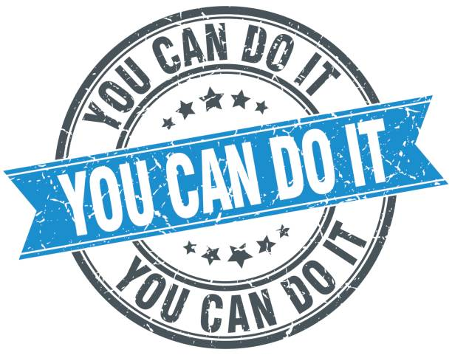
- The completed proposal for action form.

- Bibliography/ Works Cited page.

Your TRI-BOARD should have the following on it (for both the presentation and project exhibition)…

- Title of project

- Explanation of project (add details of the project)

- Process journal extracts: drawings, diagrams, video documentary, any voice recordings have to be transcribed, surveys, graphs, tables, date, etc…

- Any supporting visual aids (pictures, photos taken throughout the service)

- Your reflection of each stage (how well you carried out the four PHASES of the project)

HOW WILL MY IB COMMUNITY

PROJECT BE GRADED??

**the following rubrics will be used to grade each of the four phases of the project**

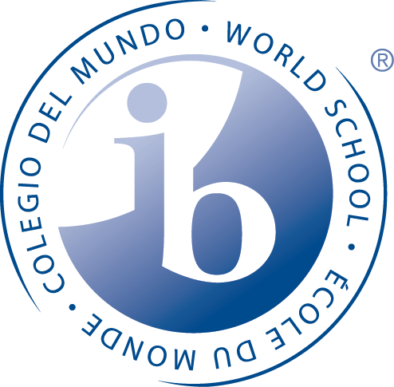
Criterion A: Investigating (phase 1a-1b)
Maximum: 8

In the community project, students should:
- Define a goal to address a need within a community, based on personal interests.
- Identify prior learning and subject-specific know ledge relevant to the project.
- Demonstrate research skills.

Achievement level | Level descriptor
0 | Students do not achieve a standard described by any of the descriptors below .
1–2 | Students are able to:  i. state a goal to address a need within a community, based on personal interests, but this may be  limited in depth or accessibility  - identify prior learning and subject-specific know ledge, but this may be limited in occurrence or relevance  - demonstrate limited research skills.
3–4 | Students are able to:  - outline an adequate goal to address a need within a community, based on personal interests  - identify basic prior learning and subject-specific know ledge relevant to  some areas of the project  iii. demonstrate adequate research skills.
5–6 | Students are able to:  i. define a clear and challenging goal to address a need w ithin a community, based on personal interests  i. identify prior learning and subject-specific know ledge generally relevant  to the project  iii. demonstrate substantial research skills.
7–8 | Students are able to:  - efine a clear and highly challenging goal to address a need w ithin a community, based on personal interests  - identify prior learning and subject-specific know ledge that is consistently highly relevant to the project  - demonstrate excellent research skills.

Criteria B: Planning (phase 2)
Maximum: 8

In the community project, students should:
  - develop a proposal for action to serve the need in the community
  - plan and record the development process of the project
  - demonstrate self-management skills.

Achievement level | Level descriptor
0 | Students do not achieve a standard described by any of the descriptors below .
1–2 | Students are able to:  - develop a limited proposal for action to serve the need in the community  - present a limited or partial plan and record of the development process of the project  - demonstrate limited self-management skills.
3–4 | Students are able to:  - develop an adequate proposal for action to serve the need in the community  - present an adequate plan and record of the development process of the project  - demonstrate adequate self-management skills.
5–6 | Students are able to:  - develop a suitable proposal for action to serve the need in the community  - present a substantial plan and record of the development process of the project  - demonstrate substantial self-management skills.
7–8 | Students are able to:  - develop a detailed, appropriate and thoughtful proposal for action to serve the need in the community  - present a detailed and accurate plan and record of the development process of the project  - demonstrate excellent self-management skills.

Criterion C: Taking action (phase 3)
Maximum: 8

In the community project, students should:
    - create a product/outcome in response to the goal,
global context and criteria

    - demonstrate thinking skills

    - Demonstrate communication and social skills.

Achievement level | Level descriptor
0 | The student does not achieve a standard described by any of the descriptors below.
1–2 | The student is able to:  - create a limited product/outcome in response to the goal, global context and criteria  - demonstrate limited thinking skills  - demonstrate limited communication and social skills.
3–4 | The student is able to:  - create a basic product/outcome in response to the goal, global context and criteria  - demonstrate adequate thinking skills  - demonstrate adequate communication and social skills.
5–6 | The student is able to:  i. create a substantial product/outcome in response to the goal, global context and criteria  ii. demonstrate substantial thinking skills  iii. demonstrate substantial communication and social skills.
7–8 | The student is able to:  i. create an excellent product/outcome in response to the goal, global context and criteria  ii. demonstrate excellent thinking skills  iii. demonstrate excellent communication and social skills.

Criterion D: Reflecting (phase 4)

Maximum: 8

In the community project, students should:
- evaluate the quality of the product/outcome against their criteria

- reflect on how completing the project has extended their
knowledge and understanding of the topic and the global context

- reflect on their development as IB learners through the project.

Achievement level | Level descriptor
0 | The student does not achieve a standard described by any of the descriptors below.
1–2 | The student is able to:  i. present a limited evaluation of the quality of the product/outcome against his or her criteria  i. present limited reflection on how completing the project has extended his or her knowledge and understanding of the topic and the global context  i. present limited reflection on his or her development as an IB learner through the project.
3–4 | The student is able to:  i. present a basic evaluation of the quality of the product/outcome against his or her criteria  i. present adequate reflection on how completing the project has extended his or her knowledge and understanding of the topic and the global context  i. present adequate reflection on his or her development as an IB learner through the project.
5–6 | The student is able to:  i. present a substantial evaluation of the quality of the product/outcome against his or her criteria  i. present substantial reflection on how completing the project has extended his or her knowledge and understanding of the topic and the global context  i. present substantial reflection on his or her development as an IB learner through the project.
7–8 | The student is able to:  i. present an excellent evaluation of the quality of the product/outcome against his or her criteria  i. present excellent reflection on how completing the project has extended his or her knowledge and understanding of the topic and the global context  i. present excellent reflection on his or her development as an IB learner through the project.

Academic Honesty Form
(to be turned in to your supervisor)
Student |  |  |  |  | FLEX teacher
School
Supervisor
Student: This document records your progress and the nature of your discussion with your supervisor. You should aim to see your supervisor at least three times: at the start of the process to discuss your initial ideas, then once you have completed a significant amount of your project, and finally once you have completed the action part of your project and are starting the final phase (you may set up additional meetings with your supervisor – if needed).
Supervisor: You are asked to have at least three supervision sessions with students, one at the start of the process, an interim meeting and then the final meeting. Other sessions are permitted but do not need to be recorded on this sheet. After each session, students should document a summary of what was discussed, and you should sign and date these comments. In addition, the supervisor MUST FILL OUT the Google Form for Checkpoints 1-3 (for each student that you supervise).
 |  | Date | Main Points Discussed | Supervisor Feedback |  | Supervisor and Student Initials
Meeting 1
Meeting 2
Meeting 3

Supervisor Final Comments:
Student Declaration
I confirm that this work is my own and this is the final version. I have acknowledged, in the body of my work, each use of the words, work or ideas of another person, whether written, oral or visual (hard copy and/or electronic materials).

Supervisor declaration
I confirm that, to the best of my knowledge, the material submitted/ presented is the authentic work of the student.
Student’s signature | Date
Supervisor’s signature | Date

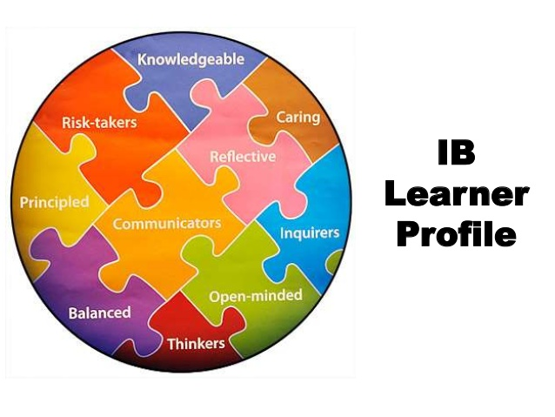

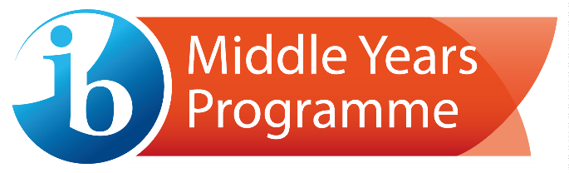

COMMUNITY PROJECT PROPOSAL
(a copy of this is to be turned in to your supervisor)
Project topic/issuee:
Student (s): |  | DEN teacher:
Supervisor:

Goal: Identify a goal to address a need in the community, based on your personal interests.
Target Audience for Your Action: Who will your project benefit? How will your project make a difference?
Process Journal: In what form have you been recording your information and reflections? (examples: visual, digital journal, audio, audio to text “Dragon app”)
Action: What will you do to make a contribution towards addressing the problem in the community in order to meet your goal? (examples: PSA, Fundraiser, Speech, Performance Art, Visual, Innovation/Problem solving, write an article for the local paper, etc.)

Extra Challenge:
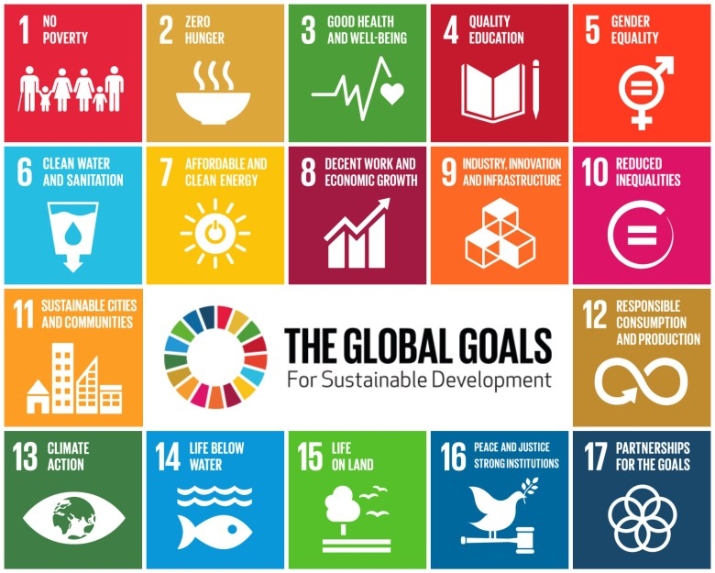

Can you align your project with one of the United Nations’ Sustainable Development Goals?

